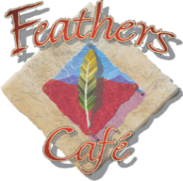

Monthly Special |17.99
Spicy Crispy Chicken Sandwich

Crispy chicken smothered in zesty buffalo sauce and finished with fresh lettuce, tomatoes, pickles, and onions. Served with your choice of side.
Available daily after 1030 AM (Nevada time).

Father’s Day |21.99
BBQ Brisket Sandwich

Smoky, tender BBQ brisket piled onto a toasted Amoroso roll with crisp pickles and creamy coleslaw. Served with your choice of side.
Available on Sunday, June 21, 2026, after 1030 AM (Nevada time).

