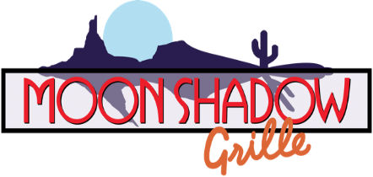

Thanksgiving Day Celebration
Thursday, November 27, 2025 | 1 PM – 8 PM
Join us for a memorable holiday dining experience featuring festive starters, chef-crafted entrées, and decadent desserts.

Starters
Shrimp Cocktail | 16
Chilled jumbo shrimp served with zesty house-made cocktail sauce and lemon.
Spicy Green Chile Queso with House-Made Tortilla Chips | 14
Warm, creamy queso infused with roasted green chiles, paired with crisp tortilla chips.
Traditional Bruschetta | 14
Toasted baguette topped with a fresh blend of tomatoes, basil, garlic, and olive oil.

Today’s Feature
Traditional Turkey Dinner with Fresh Cranberry Sauce | 50
A classic Thanksgiving feast presented with elevated seasonal flavors.
Starter:
Choice of Pumpkin Bisque or House Salad
Entrée:
Roasted turkey served with cornbread stuffing, mashed potatoes topped with rich giblet gravy, Southern-style cornbread dressing, green bean casserole, and house-made cranberry sauce.
Includes warm bread service with butter.
Dessert:
Pumpkin Pie, Granny Smith Caramel Apple Pie, or New York Cheesecake

Featured Entrées
Each entrée includes your choice of Pumpkin Bisque or House Salad.
Slow-Roasted Prime Rib
Tender, hand-carved prime rib slow-roasted to perfection.
King Cut | 60 Queen Cut | 52
Filet with Peppercorn Sauce | 56
A 6-ounce pepper-crusted filet grilled to your liking, finished with a silky hollandaise sauce.
Grilled Chilean Seabass Oscar | 64
An 8-ounce fresh seabass filet crowned with lump crab, tender asparagus, and velvety hollandaise.
Rack of Lamb | 53
Mesquite-grilled rack of lamb featuring a beautiful char and served with classic mint jelly and demi-glace.
Pumpkin Hummus Linguini | 35
Linguini tossed in a creamy pumpkin-infused hummus for a warm seasonal twist.
Add Chicken | 41 Add Shrimp | 44

Entrée Accompaniments
All entrées include Chef’s vegetable of the day and your choice of one side:
• Green Bean Casserole
• Mashed Potatoes & Gravy
• Wild Pecan Cranberry Rice
• French Fries
• Baked Potato
All dinners include MoonShadow Grille’s signature bread service with butter.

Add a Dessert
New York Cheesecake | 14
Rich, creamy cheesecake served plain or topped with strawberry, chocolate truffle, or salted caramel.
Pumpkin Pie | 11
A holiday classic with warm spices and flaky crust.
Granny Smith Caramel Apple Pie | 12
Sweet caramel and tart Granny Smith apples baked into a comforting seasonal favorite.

Please Note:
MoonShadow Grille’s regular menu and Two for $60 menu will not be available today.

