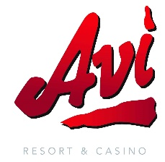

Memorial Day Menu
Sunday, May 24, 2026

Native Harvest Buffet
8AM — 2PM (NEVADA TIME)

ENTRÉES
BBQ pulled pork |BBQ Chicken |Fried Chicken | Mashed potatoes and gravy |AVI potatoes |Seasoned corn| Fried scallops, clams, and fish |Hushpuppies |Dinner rolls and butter

BREAKFAST STATION
Scrambled Eggs |Bacon |Ham |Sausage l Corned beef hash
Breakfast potatoes

FIESTA STATION
Chilaquiles | Beef and chicken fajitas |Menudo |Spanish rice | Refried beans | Tortilla chips | Nacho cheese sauce | Flour tortillas

SAUTE STATION
Eggs and Omelets to Order

SALAD BAR
Mixed greens with assorted toppings and dressings | Potato salad Three bean salad | Italian pasta salad | Caprese | Cocktail shrimp | Ambrosia | Strawberry and spinach salad

SOUP
Beef Barley

DESSERTS
Assorted cakes and pies | Sugar-free desserts
Soft serve ice cream

Adults | $19.99
Children (ages 4 – 10) | $12.99

Champagne, Mimosas, Bloody Mary’s, Poinsettias, Beer and Wine Available for Purchase

